CRYPT-ARITHMETIC PROBLEM
Aim
To develop a program that solves a crypt-arithmetic puzzle by assigning unique digits to letters such that the arithmetic equation is satisfied.

Objectives
- To understand the concept of crypt-arithmetic puzzles.
- To assign unique digits (0–9) to letters.
- To solve the puzzle using the Backtracking algorithm.
- To verify whether the arithmetic equation is correct.
- To display the valid digit assignment.
Algorithm (Backtracking)
- Input the crypt-arithmetic expression (e.g., SEND + MORE = MONEY).
- Extract all unique letters from the words.
- Assign digits (0–9) to letters one by one.
- Ensure no two letters have the same digit.
- Do not assign 0 to the leading letter of any word.
- Form the corresponding numbers using the assigned digits.
- Check whether the arithmetic equation is satisfied.
- If valid, display the solution; otherwise, backtrack and try another assignment.
- Repeat until a solution is found or all possibilities are checked.
Flowchart
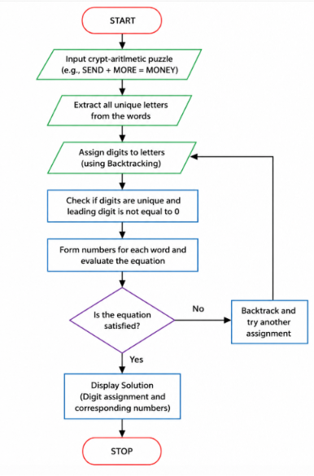
Code
from itertools import permutations

letters = "SENDMORY"

for p in permutations("0123456789", len(letters)):
d = dict(zip(letters, p))

# Leading letters cannot be zero
if d['S'] == '0' or d['M'] == '0':
continue

send = int(d['S'] + d['E'] + d['N'] + d['D'])
more = int(d['M'] + d['O'] + d['R'] + d['E'])
money = int(d['M'] + d['O'] + d['N'] + d['E'] + d['Y'])

if send + more == money:
print("Solution Found!")
for key, value in sorted(d.items()):
print(key, "=", value)

print("\nSEND =", send)
print("MORE =", more)
print("MONEY =", money)
print("\n", send, "+", more, "=", money)
break
Output
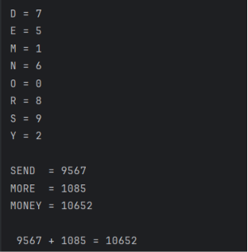
Result
The crypt-arithmetic puzzle is solved successfully using the Backtracking algorithm by assigning unique digits to each letter while satisfying the arithmetic equation.

